
Godstone Primary School Maths Policy UKS2
KS1 Maths Calculation Policy

Doha British School
UKS2 Maths Calculation Policy
KEY STAGE 2
In upper Key Stage 2, children build on secure foundations in calculation, and develop fluency, accuracy and flexibility in their approach to the four operations. They work with whole numbers and adapt their skills to work with decimals, and they continue to develop their ability to select appropriate, accurate and efficient operations.
Key language: decimal, column methods, exchange, partition, mental method, ten thousand, hundred thousand, million, factor, multiple, prime number, square number, cube number
Addition and subtraction:  Children build on their column methods to add and subtract numbers with up to seven digits, and they adapt the methods to calculate efficiently and effectively with decimals, ensuring understanding of place value at every stage.  Children compare and contrast methods, and they select mental methods or jottings where appropriate and where these are more likely to be efficient or accurate when compared with formal column methods.  Bar models are used to represent the calculations required to solve problems and may indicate where efficient methods can be chosen. | Multiplication and division:  Building on their understanding, children develop methods to multiply up to 4-digit numbers by single-digit and 2-digit numbers.  Children develop column methods with an understanding of place value, and they continue to use the key skill of unitising to multiply and divide by 10, 100 and 1,000.  Written division methods are introduced and adapted for division by single-digit and 2-digit numbers and are understood alongside the area model and place value. In Year 6, children develop a secure understanding of how division is related to fractions.  Multiplication and division of decimals are also introduced and refined in Year 6.

Year 5
 | Concrete | Pictorial | Abstract
Year 5 Addition
Column addition with whole numbers | Use place value equipment to represent additions.  Add a row of counters onto the place value grid to show 15,735 + 4,012.  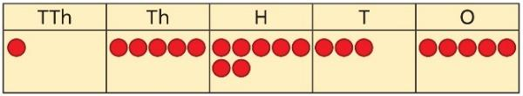 | Represent additions, using place value equipment on a place value grid alongside written methods.  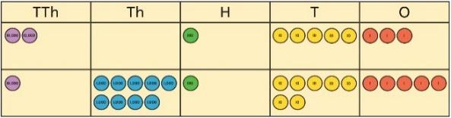  I need to exchange 10 tens for a 100.  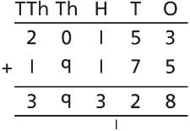 | Use column addition, including exchanges.  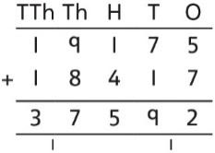
Representing additions |  | Bar models represent addition of two or more numbers in the context of problem solving.  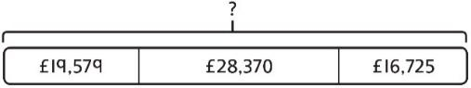  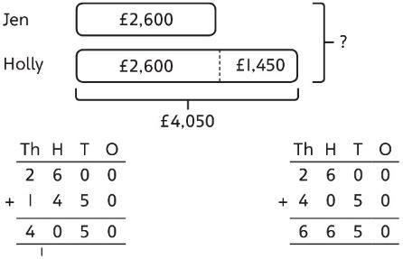 | Use approximation to check whether answers are reasonable.  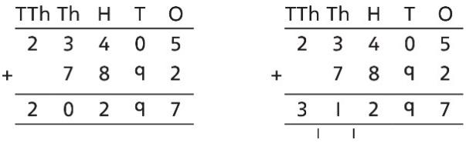  I will use 23,000 + 8,000 to check.
Adding tenths | Link measure with addition of decimals.  Two lengths of fencing are 0·6 m and  0·2 m.  How long are they when added together?  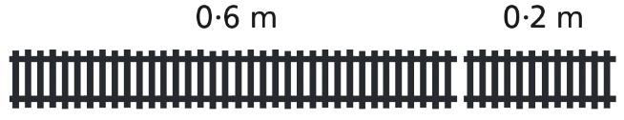 | Use a bar model with a number line to add tenths.  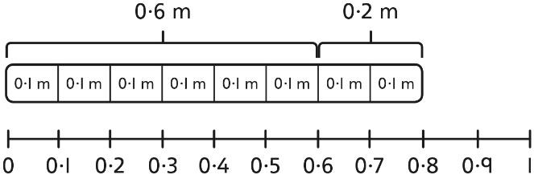  0·6 + 0·2 = 0·8  6 tenths + 2 tenths = 8 tenths | Understand the link with adding fractions.  $$\frac{6}{10}+\frac{2}{10}=\frac{8}{10}$$  6 tenths + 2 tenths = 8 tenths  0·6 + 0·2 = 0·8
Adding decimals using column addition | Use place value equipment to represent additions.  Show 0·23 + 0·45 using place value counters. | Use place value equipment on a place value grid to represent additions.  Represent exchange where necessary.  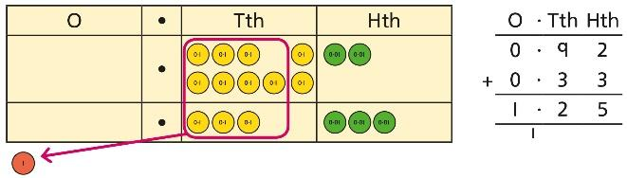  Include examples where the numbers of decimal places are different.  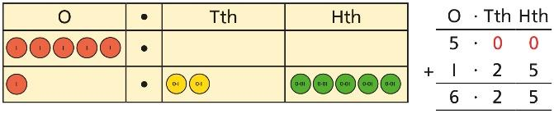 | Add using a column method, ensuring that children understand the link with place value.  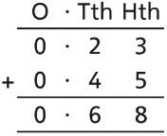  Include exchange where required, alongside an understanding of place value.  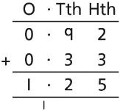  Include additions where the numbers of decimal places are different.  3.4 + 0.65 = ?  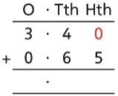
Year 5 Subtraction
Column subtraction with whole numbers | Use place value equipment to understand where exchanges are required.  2,250 – 1,070  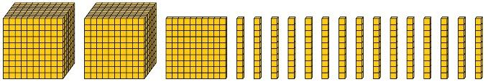 | Represent the stages of the calculation using place value equipment on a grid alongside the calculation, including exchanges where required.  15,735 − 2,582 = 13,153  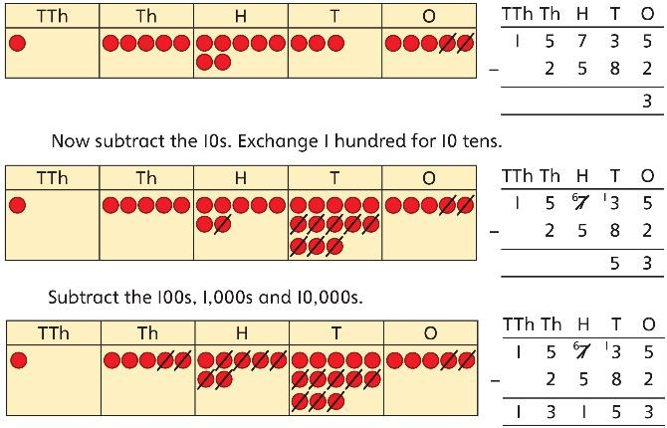 | Use column subtraction methods with exchange where required.  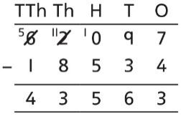  62,097 − 18,534 = 43,563
Checking strategies and representing subtractions |  | Bar models represent subtractions in problem contexts, including ‘find the difference’.  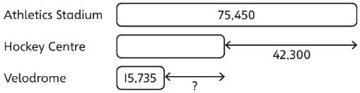 | Children can explain the mistake made when the columns have not been ordered correctly.  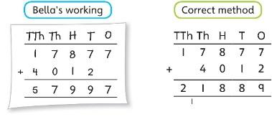  Use approximation to check calculations.  I calculated 18,000 + 4,000 mentally to check my subtraction.
Choosing efficient methods |  |  | To subtract two large numbers that are close, children find the difference by counting on.  2,002 − 1,995 = ?  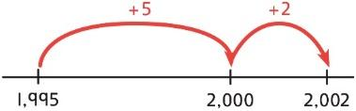  Use addition to check subtractions.  I calculated 7,546 − 2,355 = 5,191.  I will check using the inverse.
Subtracting decimals | Explore complements to a whole number by working in the context of length.  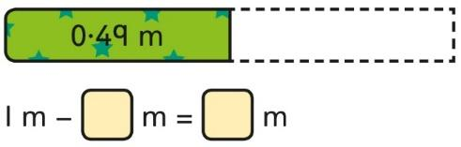  1 − 0·49 = ? | Use a place value grid to represent the stages of column subtraction, including exchanges where required.  5·74 − 2·25 = ?  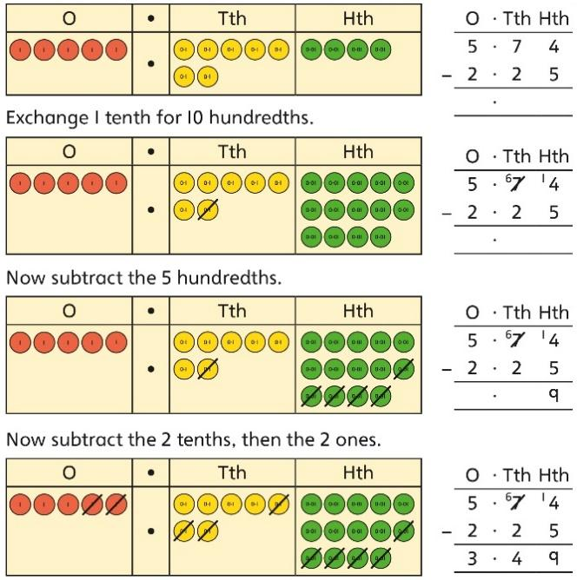 | Use column subtraction, with an understanding of place value, including subtracting numbers with different numbers of decimal places.  3·921 − 3·75 = ?  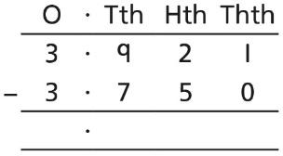
Year 5 Multiplication
Understanding factors | Use cubes or counters to explore the meaning of ‘square numbers’.  25 is a square number because it is made from 5 rows of 5.  Use cubes to explore cube numbers.  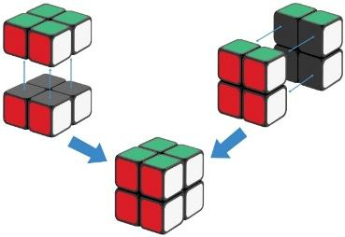  8 is a cube number. | Use images to explore examples and non-examples of square numbers.  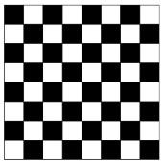  8 × 8 = 64  8² = 64  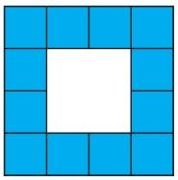  12 is not a square number, because you cannot multiply a whole number by itself to make 12. | Understand the pattern of square numbers in the multiplication tables.  Use a multiplication grid to circle each square number. Can children spot a pattern?
Multiplying by 10, 100 and 1,000 | Use place value equipment to multiply by 10, 100 and 1,000 by unitising.  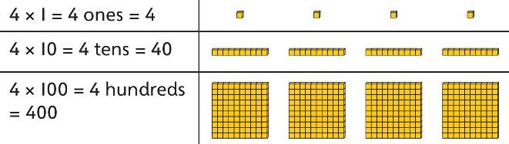 | Understand the effect of repeated multiplication by 10.  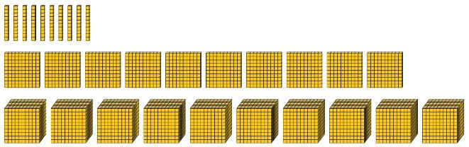 | Understand how exchange relates to the digits when multiplying by 10, 100 and 1,000.  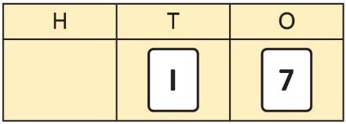  17 × 10 = 170  17 × 100 = 17 × 10 × 10 = 1,700  17 × 1,000 = 17 × 10 × 10 × 10 = 17,000
Multiplying by multiples of 10, 100 and 1,000 | Use place value equipment to explore multiplying by unitising.  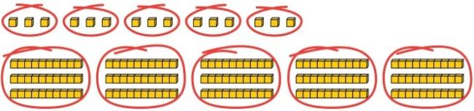  5 groups of 3 ones is 15 ones.  5 groups of 3 tens is 15 tens.  So, I know that 5 groups of 3 thousands would be 15 thousands. | Use place value equipment to represent how to multiply by multiples of 10, 100 and 1,000.  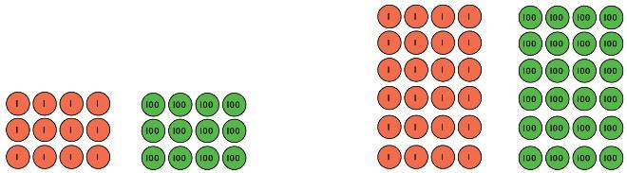  4 × 3 = 12 6 × 4 = 24  4 × 300 = 1,200 6 × 400 = 2,400 | Use known facts and unitising to multiply.  5 × 4 = 20  5 × 40 = 200  5 × 400 = 2,000  5 × 4,000 − 20,000  5,000 × 4 = 20,000
Multiplying up to 4-digit numbers by a single digit | Explore how to use partitioning to multiply efficiently.  8 × 17 = ?  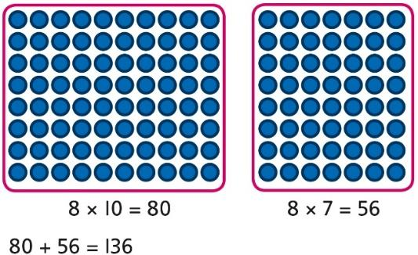  So, 8 × 17 = 136 | Represent multiplications using place value equipment and add the 1s, then 10s, then 100s, then 1,000s.  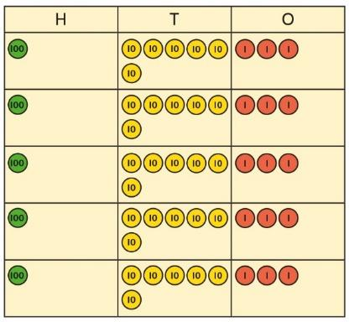 | Use an area model and then add the parts.  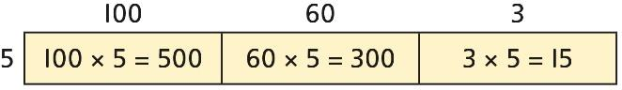  Use a column multiplication, including any required exchanges.  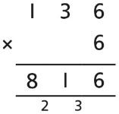
Multiplying 2-digit numbers by 2-digit numbers | Partition one number into 10s and 1s, then add the parts.  23 × 15 = ?  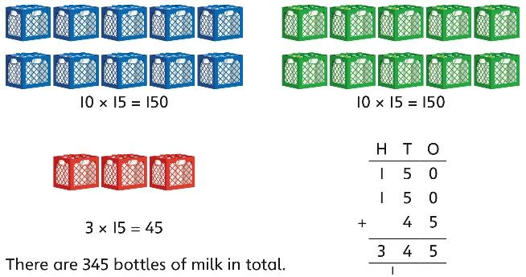  23 × 15 = 345 | Use an area model and add the parts.  28 × 15 = ?  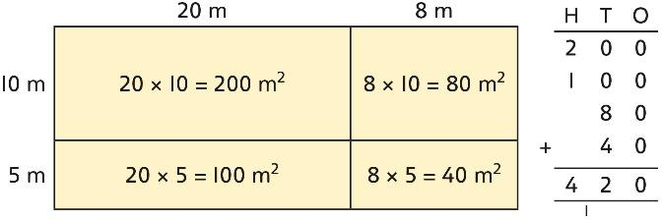  28 × 15 = 420 | Use column multiplication, ensuring understanding of place value at each stage.  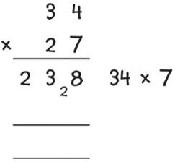  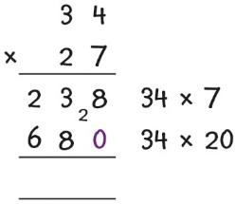  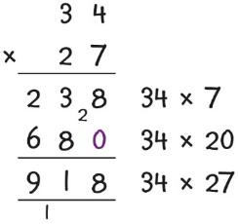
Multiplying up to 4-digits by 2-digits |  | Use the area model then add the parts.  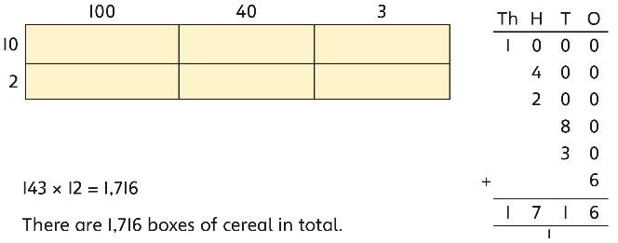  143 × 12 = 1,716 | Use column multiplication, ensuring understanding of place value at each stage.  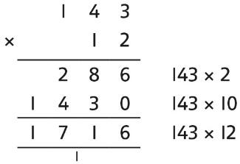  Progress to include examples that require multiple exchanges as understanding, confidence and fluency build.  1,274 × 32 = ?  First multiply 1,274 by 2.  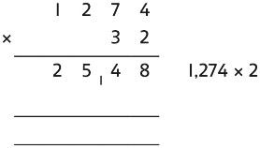  Then multiply 1,274 by 30.  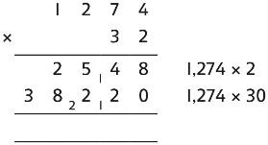  Finally, find the total.  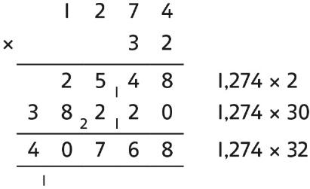  1,274 × 32 = 40,768
Multiplying decimals by 10, 100 and 1,000 | Use place value equipment to explore and understand the exchange of 10 tenths, 10 hundredths or 10 thousandths. | Represent multiplication by 10 as exchange on a place value grid.  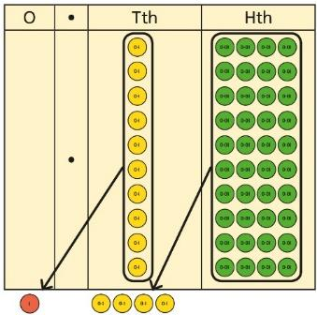  0·14 × 10 = 1·4 | Understand how this exchange is represented on a place value chart.  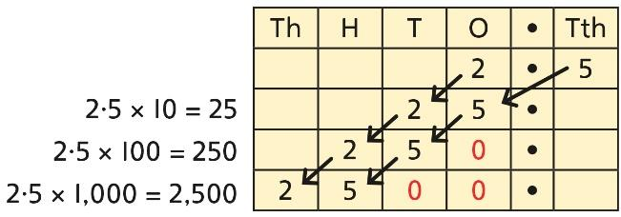
Year 5 Division
Understanding factors and prime numbers | Use equipment to explore the factors of a given number.    24 ÷ 3 = 8  24 ÷ 8 = 3  8 and 3 are factors of 24 because they divide 24 exactly.  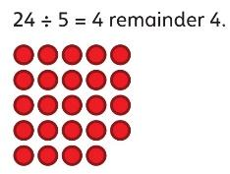  5 is not a factor of 24 because there is a remainder. | Understand that prime numbers are numbers with exactly two factors.  13 ÷ 1 = 13  13 ÷ 2 = 6 r 1  13 ÷ 4 = 4 r 1  1 and 13 are the only factors of 13.  13 is a prime number. | Understand how to recognise prime and composite numbers.  I know that 31 is a prime number because it can be divided by only 1 and itself without leaving a remainder.  I know that 33 is not a prime number as it can be divided by 1, 3, 11 and 33.  I know that 1 is not a prime number, as it has only 1 factor.
Understanding inverse operations and the link with multiplication, grouping and sharing | Use equipment to group and share and to explore the calculations that are present.  I have 28 counters.  I made 7 groups of 4. There are 28 in total.  I have 28 in total. I shared them equally into 7 groups. There are 4 in each group.  I have 28 in total. I made groups of 4. There are 7 equal groups. | Represent multiplicative relationships and explore the families of division facts.  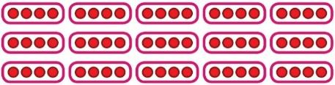  60 ÷ 4 = 15  60 ÷ 15 = 4 | Represent the different multiplicative relationships to solve problems requiring inverse operations.  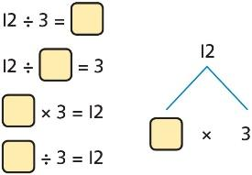  Understand missing number problems for division calculations and know how to solve them using inverse operations.  22 ÷ ? = 2  22 ÷ 2 = ?  ? ÷ 2 = 22  ? ÷ 22 = 2
Dividing whole numbers by 10, 100 and 1,000 | Use place value equipment to support unitising for division.  4,000 ÷ 1,000  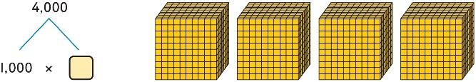  4,000 is 4 thousands.  4 × 1,000= 4,000  So, 4,000 ÷ 1,000 = 4 | Use a bar model to support dividing by unitising.  380 ÷ 10 = 38  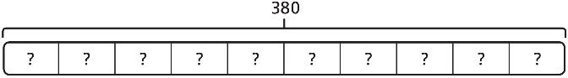  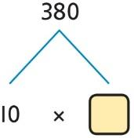  380 is 38 tens.  38 × 10 = 380  10 × 38 = 380  So, 380 ÷ 10 = 38 | Understand how and why the digits change on a place value grid when dividing by 10, 100 or 1,000.  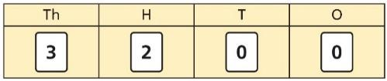  3,200 ÷ 100 = ?  3,200 is 3 thousands and 2 hundreds.  200 ÷ 100 = 2  3,000 ÷ 100 = 30  3,200 ÷ 100 = 32  So, the digits will move two places to the right.
Dividing by multiples of 10, 100 and 1,000 | Use place value equipment to represent known facts and unitising.  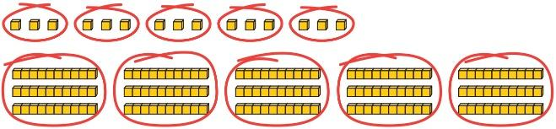  15 ones put into groups of 3 ones. There are 5 groups.  15 ÷ 3 = 5  15 tens put into groups of 3 tens. There are 5 groups.  150 ÷ 30 = 5 | Represent related facts with place value equipment when dividing by unitising.  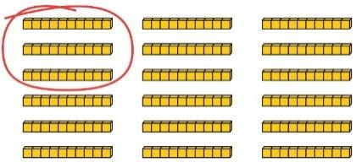  180 is 18 tens.  18 tens divided into groups of 3 tens. There are 6 groups.  180 ÷ 30 = 6  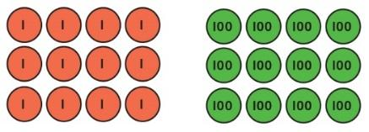  12 ones divided into groups of 4. There are 3 groups.  12 hundreds divided into groups of 4 hundreds. There are 3 groups.  1200 ÷ 400 = 3 | Reason from known facts, based on understanding of unitising. Use knowledge of the inverse relationship to check.  3,000 ÷ 5 = 600  3,000 ÷ 50 = 60  3,000 ÷ 500 = 6  5 × 600 = 3,000  50 × 60 = 3,000  500 × 6 = 3,000
Dividing up to four digits by a single digit using short division | Explore grouping using place value equipment.  268 ÷ 2 = ?  There is 1 group of 2 hundreds.  There are 3 groups of 2 tens.  There are 4 groups of 2 ones.  264 ÷ 2 = 134 | Use place value equipment on a place value grid alongside short division.  The model uses grouping.  A sharing model can also be used, although the model would need adapting.  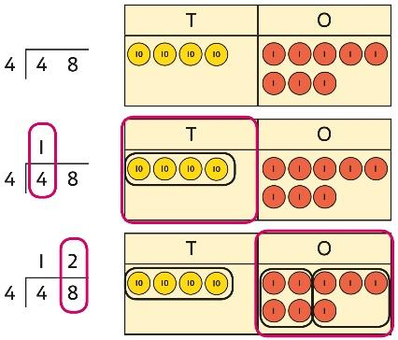  Lay out the problem as a short division.  There is 1 group of 4 in 4 tens.  There are 2 groups of 4 in 8 ones.  Work with divisions that require exchange.  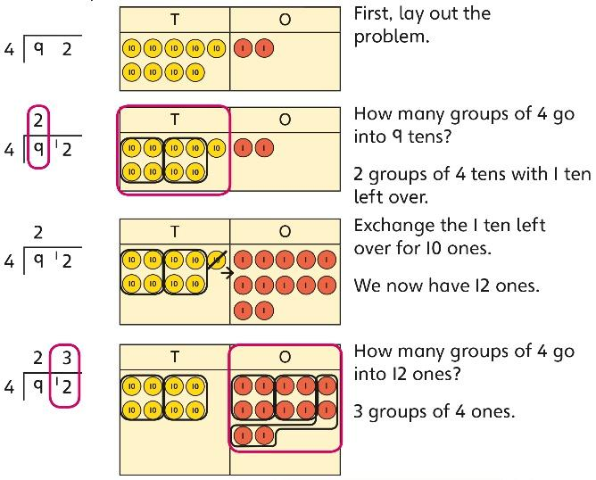 | Use short division for up to 4-digit numbers divided by a single digit.  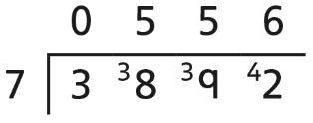  3,892 ÷ 7 = 556  Use multiplication to check.  556 × 7 = ?  6 × 7 = 42  50 × 7 = 350  500 × 7 = 3500  3,500 + 350 + 42 = 3,892
Understanding remainders | Understand remainders using concrete versions of a problem.  80 cakes divided into trays of 6.  80 cakes in total. They make 13 groups of 6, with 2 remaining. | Use short division and understand remainders as the last remaining 1s.  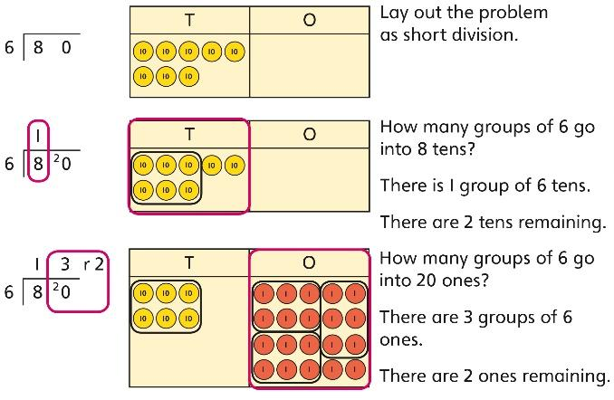 | In problem solving contexts, represent divisions including remainders with a bar model.  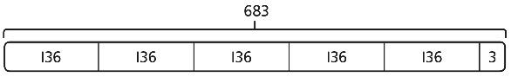  683 = 136 × 5 + 3  683 ÷ 5 = 136 r 3
Dividing decimals by 10, 100 and 1,000 | Understand division by 10 using exchange.  2 ones are 20 tenths.  20 tenths divided by 10 is 2 tenths. | Represent division using exchange on a place value grid.  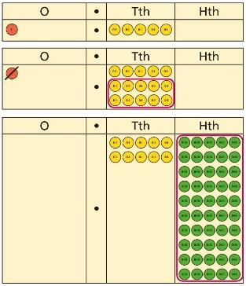  1·5 is 1 one and 5 tenths.  This is equivalent to 10 tenths and 50 hundredths.  10 tenths divided by 10 is 1 tenth.  50 hundredths divided by 10 is 5 hundredths.  1·5 divided by 10 is 1 tenth and 5 hundredths.  1·5 ÷ 10 = 0.15 | Understand the movement of digits on a place value grid.  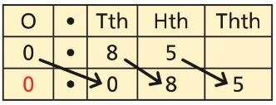  0·85 ÷ 10 = 0·085  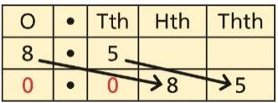  8·5 ÷ 100 = 0·085
Understanding the relationship between fractions and division | Use sharing to explore the link between fractions and division.  1 whole shared between 3 people.  Each person receives one-third.  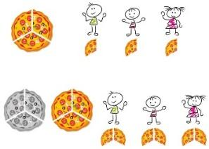 | Use a bar model and other fraction representations to show the link between fractions and division.  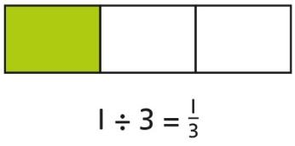 | Use the link between division and fractions to calculate divisions.  $$5÷4=\frac{5}{4}=1\frac{1}{4}$$  $$11 ÷4=\frac{11}{4}=2\frac{3}{4}$$
Year 6
 | Concrete | Pictorial | Abstract
Year 6 Addition
Comparing and selecting efficient methods | Represent 7-digit numbers on a place value grid, and use this to support thinking and mental methods.  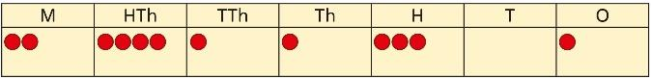 | Discuss similarities and differences between methods, and choose efficient methods based on the specific calculation.  Compare written and mental methods alongside place value representations.  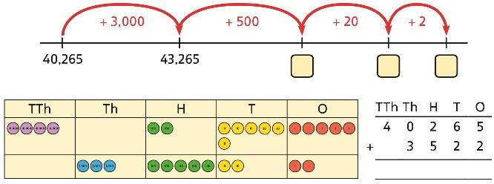  Use bar model and number line representations to model addition in problem-solving and measure contexts.  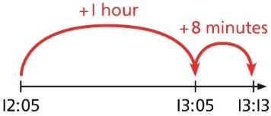 | Use column addition where mental methods are not efficient. Recognise common errors with column addition.  32,145 + 4,302 = ?  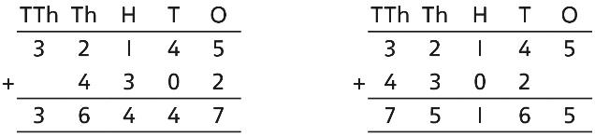  Which method has been completed accurately?  What mistake has been made?  Column methods are also used for decimal additions where mental methods are not efficient.  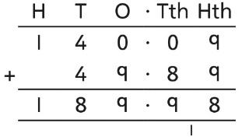
Selecting mental methods for larger numbers where appropriate | Represent 7-digit numbers on a place value grid, and use this to support thinking and mental methods.  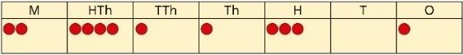  2,411,301 + 500,000 = ?  This would be 5 more counters in the HTh place.  So, the total is 2,911,301.  2,411,301 + 500,000 = 2,911,301 | Use a bar model to support thinking in addition problems.  257,000 + 99,000 = ?  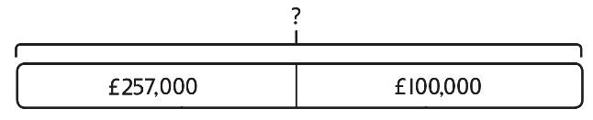  I added 100 thousands then subtracted  1 thousand.  257 thousands + 100 thousands = 357 thousands  257,000 + 100,000 = 357,000  357,000 – 1,000 = 356,000  So, 257,000 + 99,000 = 356,000 | Use place value and unitising to support mental calculations with larger numbers.  195,000 + 6,000 = ?  195 + 5 + 1 = 201  195 thousands + 6 thousands = 201 thousands  So, 195,000 + 6,000 = 201,000
Understanding order of operations in calculations | Use equipment to model different interpretations of a calculation with more than one operation. Explore different results.  3 × 5 − 2 = ?  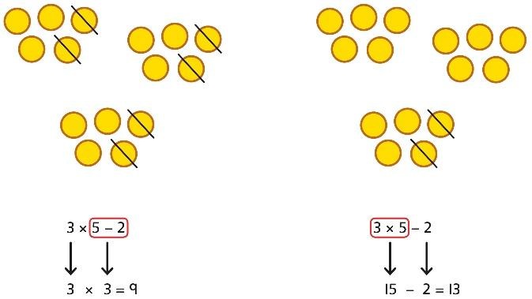 | Model calculations using a bar model to demonstrate the correct order of operations in multi-step calculations.  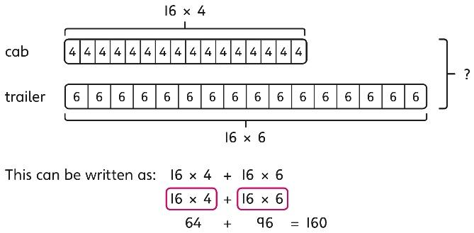 | Understand the correct order of operations in calculations without brackets.  Understand how brackets affect the order of operations in a calculation.  4 + 6 × 16  4 + 96 = 100  (4 + 6) × 16  10 × 16 = 160
Year 6 Subtraction
Comparing and selecting efficient methods | Use counters on a place value grid to represent subtractions of larger numbers.  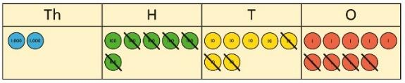 | Compare subtraction methods alongside place value representations.  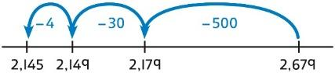  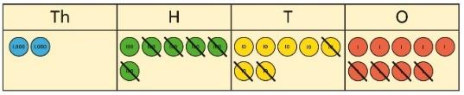  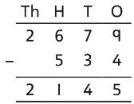  Use a bar model to represent calculations, including ‘find the difference’ with two bars as comparison.  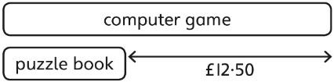 | Compare and select methods.  Use column subtraction when mental methods are not efficient.  Use two different methods for one calculation as a checking strategy.  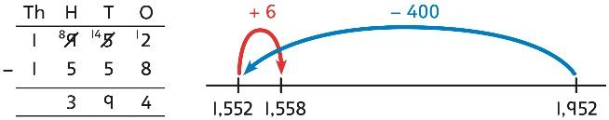  Use column subtraction for decimal problems, including in the context of measure.  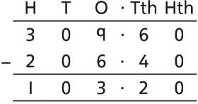
Subtracting mentally with larger numbers |  | Use a bar model to show how unitising can support mental calculations.  950,000 − 150,000  That is 950 thousands − 150 thousands  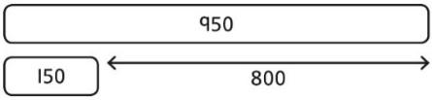  So, the difference is 800 thousands.  950,000 − 150,000 = 800,000 | Subtract efficiently from powers of 10.  10,000 − 500 = ?
Year 6 Multiplication
Multiplying up to a 4-digit number by a single digit number | Use equipment to explore multiplications.  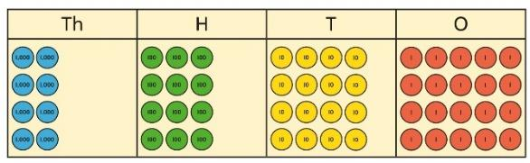  4 groups of 2,345  This is a multiplication:  4 × 2,345  2,345 × 4 | Use place value equipment to compare methods.  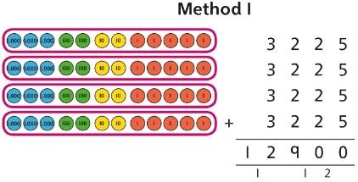  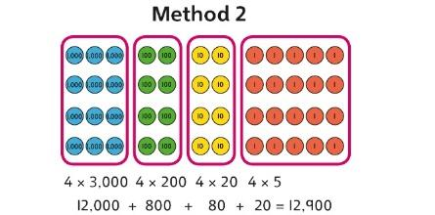 | Understand area model and short multiplication.  Compare and select appropriate methods for specific multiplications.  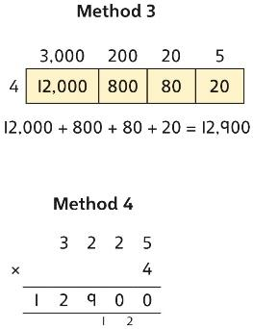
Multiplying up to a 4-digit number by a  2-digit number |  | Use an area model alongside written multiplication.  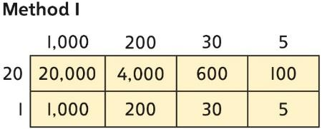  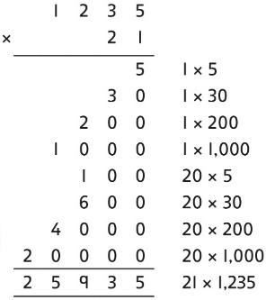 | Use compact column multiplication with understanding of place value at all stages.  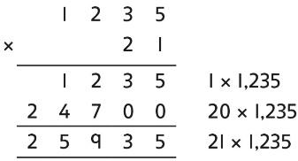
Using knowledge of factors and partitions to compare methods for multiplications | Use equipment to understand square numbers and cube numbers.  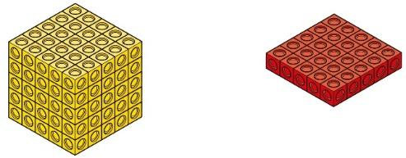  5 × 5 = 5² = 25  5 × 5 × 5 = 5³ = 25 × 5 = 125 | Compare methods visually using an area model. Understand that multiple approaches will produce the same answer if completed accurately.  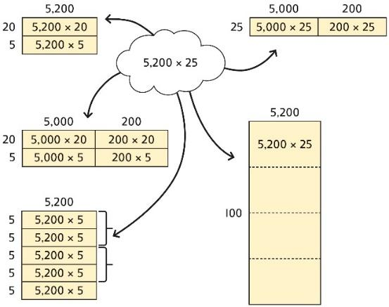  Represent and compare methods using a bar model. | Use a known fact to generate families of related facts.  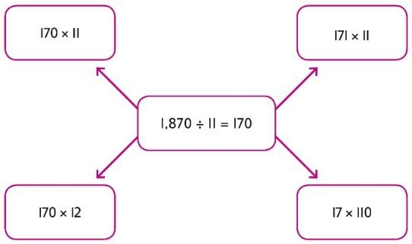  Use factors to calculate efficiently.  15 × 16  = 3 × 5 × 2 × 8  = 3 × 8 × 2 × 5  = 24 × 10  = 240
Multiplying by 10, 100 and 1,000 | Use place value equipment to explore exchange in decimal multiplication.  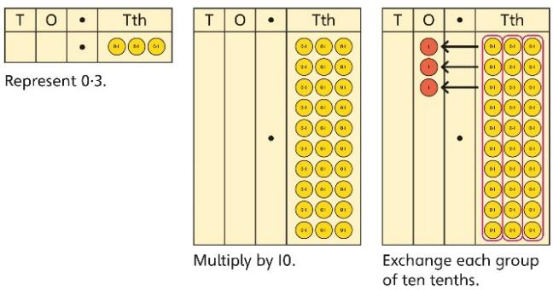  0·3 × 10 = ?  0·3 is 3 tenths.  10 × 3 tenths are 30 tenths.  30 tenths are equivalent to 3 ones. | Understand how the exchange affects decimal numbers on a place value grid.  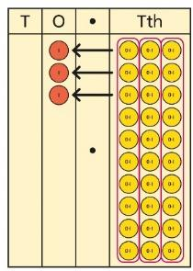  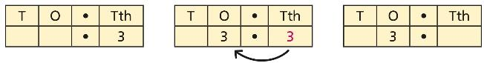  0·3 × 10 = 3 | Use knowledge of multiplying by 10, 100 and 1,000 to multiply by multiples of 10, 100 and 1,000.  8 × 100 = 800  8 × 300 = 800 × 3  = 2,400  2·5 × 10 = 25  2·5 × 20 = 2·5 × 10 × 2  = 50
Multiplying decimals | Explore decimal multiplications using place value equipment and in the context of measures.  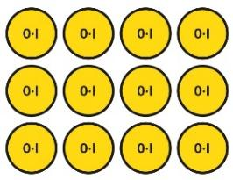  3 groups of 4 tenths is 12 tenths.  4 groups of 3 tenths is 12 tenths.  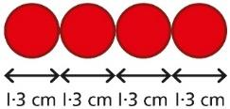  4 × 1 cm = 4 cm  4 × 0·3 cm = 1.2 cm  4 × 1·3 = 4 + 1·2 = 5·2 cm | Represent calculations on a place value grid.  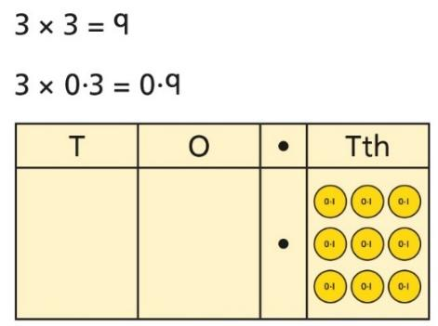  Understand the link between multiplying decimals and repeated addition.  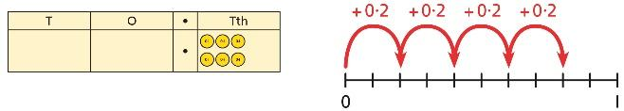 | Use known facts to multiply decimals.  4 × 3 = 12  4 × 0·3 = 1·2  4 × 0·03 = 0·12  20 × 5 = 100  20 × 0·5 = 10  20 × 0·05 = 1  Find families of facts from a known multiplication.  I know that 18 × 4 = 72.  This can help me work out:  1·8 × 4 = ?  18 × 0·4 = ?  180 × 0·4 = ?  18 × 0·04 = ?  Use a place value grid to understand the effects of multiplying decimals.  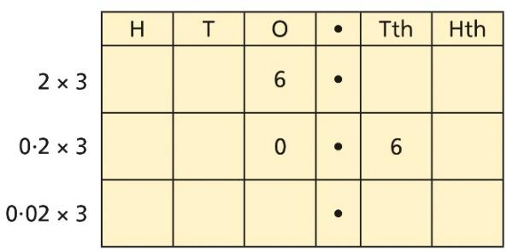
Year 6 Division
Understanding factors | Use equipment to explore different factors of a number.  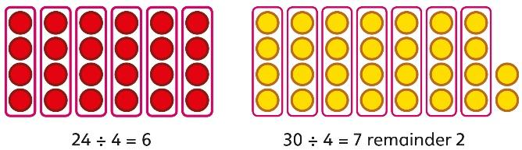  4 is a factor of 24 but is not a factor of 30. | Recognise prime numbers as numbers having exactly two factors. Understand the link with division and remainders.  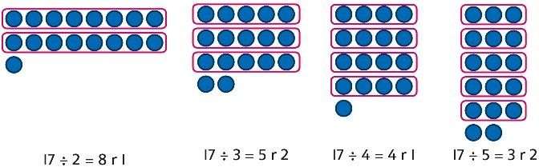 | Recognise and know primes up to 100.  Understand that 2 is the only even prime, and that 1 is not a prime number.  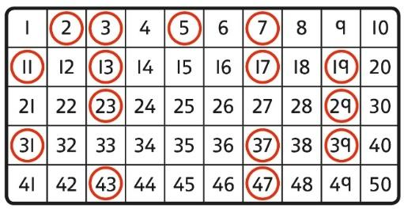
Dividing by a single digit | Use equipment to make groups from a total.  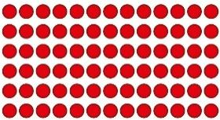  There are 78 in total.  There are 6 groups of 13.  There are 13 groups of 6. | 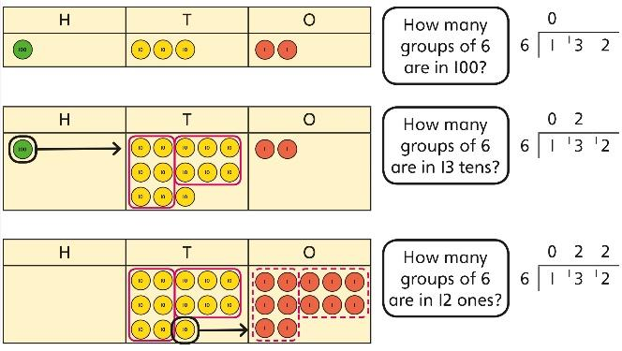 | Use short division to divide by a single digit.  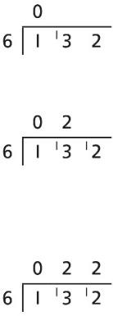  Use an area model to link multiplication and division.  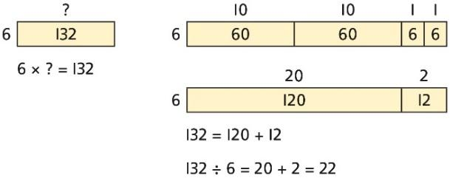
Dividing by a 2-digit number using factors | Understand that division by factors can be used when dividing by a number that is not prime. | Use factors and repeated division.  1,260 ÷ 14 = ?  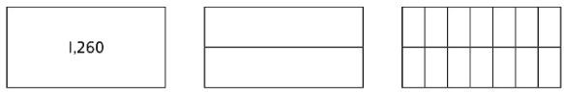  1,260 ÷ 2 = 630  630 ÷ 7 = 90  1,260 ÷ 14 = 90 | Use factors and repeated division where appropriate.  2,100 ÷ 12 = ?  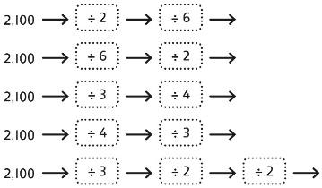
Dividing by a 2-digit number using long division | Use equipment to build numbers from groups.  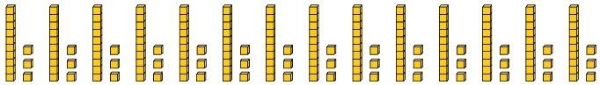  182 divided into groups of 13.  There are 14 groups. | Use an area model alongside written division to model the process.  377 ÷ 13 = ?  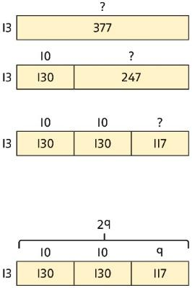  377 ÷ 13 = 29 | Use long division where factors are not useful (for example, when dividing by a  2-digit prime number).  Write the required multiples to support the division process.  377 ÷ 13 = ?  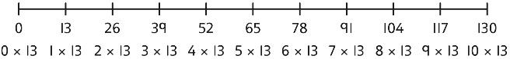  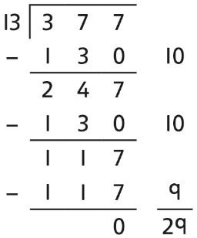  377 ÷ 13 = 29  A slightly different layout may be used, with the division completed above rather than at the side.  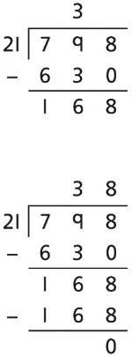  Divisions with a remainder explored in problem-solving contexts.
Dividing by 10, 100 and 1,000 | Use place value equipment to explore division as exchange.  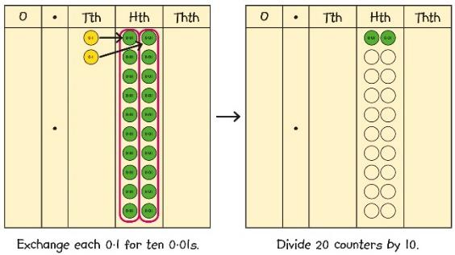  0·2 is 2 tenths.  2 tenths is equivalent to 20 hundredths.  20 hundredths divided by 10 is 2 hundredths. | Represent division to show the relationship with multiplication. Understand the effect of dividing by 10, 100 and 1,000 on the digits on a place value grid.  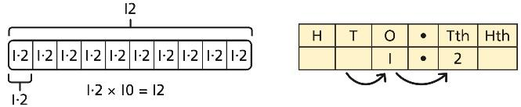  Understand how to divide using division by 10, 100 and 1,000.  12 ÷ 20 = ?  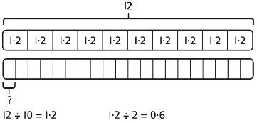 | Use knowledge of factors to divide by multiples of 10, 100 and 1,000.  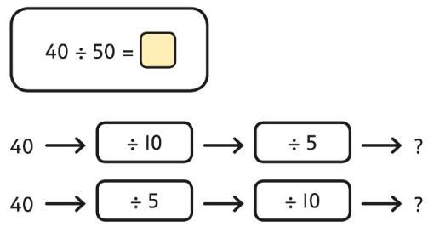  40 ÷ 5 = 8  8 ÷ 10 = 0·8  So, 40 ÷ 50 = 0·8
Dividing decimals | Use place value equipment to explore division of decimals.  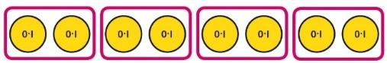  8 tenths divided into 4 groups. 2 tenths in each group. | Use a bar model to represent divisions.  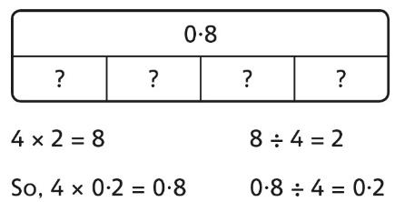 | Use short division to divide decimals with up to 2 decimal places.  

